Sample Paper of Journal of Water and Environment Technology

First Middle Family ª, Taro Yamada ^{b}, Hanako Suzuki ^{c,d}
ª Department of Environmental Engineering, Environmental University, Tokyo, Japan
^{b} Department of Water Resource Management, Water Environmental Center, Osaka, Japan
^{c} Graduate School of Water Environment, Water University, Sendai, Japan
^{d} R & D Laboratory, Water Environment Research Co., Ltd., Cityname, Countryname

ABSTRACT
Journal of Water and Environment Technology (JWET) is an official journal of the Japan Society on Water Environment (JSWE). The editorial board of JWET invites original contributions in all the subjects on scientific, technological and practical issues related with water environment. It publishes peer-reviewed original research papers and review papers submitted to the electronic review system. JSWE have already begun the electronic publication of JWET from 2004 through the webpage of J-STAGE (Japan Science and Technology Information Aggregator). Issues of JWET are available online to anybody with no limitation. Priority of this journal is to provide our important and valuable information to all people who show interest. Articles are published in PDF format, and anybody can display and print the full articles using Adobe Reader. The abstract should not exceed 200 words.

Keywords: water quality, water purification, wastewater treatment, environmental modeling, up to five key words

Corresponding author: Taro Yamada, E-mail: t_yamada@xxx.xxx.xxx
INTRODUCTION
This file is a template for a manuscript to be submitted to Journal of Water and Environment Technology (JWET). For more details, please see 'Instructions to authors', which can be found at http://www.jswe.or.jp/publications/instructions/index.html. If your paper is accepted for publication in Journal of Water and Environment Technology, you will be asked to sign our copyright transfer form.

Microsoft Word is recommended to be used for preparing the manuscripts although we accept most of the popular word-processing packages. To avoid unexpected transformations of the manuscript styles, Authors should not add their own macros and also not include the revision history and comments in the file. The upper limit of manuscript length is 6,000 words.

MATERIALS AND METHODS
Preparation of electronic versions
Articles should be provided in electronic form through the online submission site (http://mc.manuscriptcentral.com/jwet). This will help us to publish your article rapidly with fewer errors, and enable your article's inclusion in electronic archives.

The uploaded files are converted to a single PDF file at the submission website. You must confirm the PDF proof to complete your submission.

Nomenclature and units
Terminology and notation used must be widely understood. Abbreviations and acronyms should be spelled out in full at their first occurrence in the text. SI units are strongly recommended. When non-SI units are used, SI equivalents (or conversion factors) must also be given. Write equations in dimensionless form or in metric units. Use the thousands separators for the numbers such as 10,000.
(1)
E: total energy (J)
m: mass of the object (kg)
v: velocity (m/s)
g: acceleration due to gravity (m/s²)
h: height (m)
(2)
P: pressure (Pa)
V: volume (L)
n: amount of substance (mol)
R: gas constant (Pa∙L/(K∙mol))
T: temperature (K)
We accept both expression styles, mg/L and mg L^{–1} but the style should be consistent within a manuscript.

Text
Major heading
Capitalize all characters in a major heading.

Middle heading
Capitalize only the first character of the first word of a middle heading, and apply bold face.

Minor heading
Capitalize only the first character of the first word of a middle heading, and apply italic face.

Font face in main text
Use plain font for the main text. Followings are examples of exceptions.
-Genus and species names of organisms should be spelled in italic. Taxonomic names other than genus and species level should be described in plain font.
Ex) Escherichia coli, Proteobacteria (phylum, class, order, and family name in plain font)
-Symbols for equations and parameters should be spelled in italic.

DNA sequence
Nucleic acid sequences should be presented as follows: 5'-GTTAGCTACGGCACTAAAAGG-3'.

Special characters
You should avoid multibyte characters, such as Japanese letters, except for Supplementary Materials. The following characters can be used instead of those multibyte characters: %, − (as minus), - (as hyphen), ×, ±,°C, ° (as degree), ' (as apostrophe, used for longitude and latitude), ∙(as bullet for such as MgSO₄∙7H₂O, mg/(L∙h), and hydroxyl radical ∙OH). Do not use symbol font, instead, use Greek characters in Times New Roman font: α, β, ψ, δ, ε, φ, γ, η, ι, ξ, κ, λ, μ, ν, ο, π, ρ, σ, τ, θ, ω, ς, χ, υ, ζ, Δ etc.

Citation
Literature should be identified by the number used in Reference list as [1]. If the multiple literature is cited at the same time, the following style should be used [2,3], [2–5], [2,4,6] or [2,7–9]. Literature should be cited in the order of the number.

The name of manufacturer should be accompanied with information of its location (city and country) unless it is commonly recognized by international readers when it is mentioned for the first time in the text. All the figures, tables and equations given should be cited in the main text as Fig. 1, Table 1 and equation (1).

RESULTS AND DISCUSSION
Official publication
The Society publishes the monthly domestic journal in Japanese language: Journal of JSWE, its official periodical carrying various kinds of information regarding the water environment. The Society also publishes the international journal: Journal of Water and Environment Technology from online website of free access.

The Society annually holds three meetings: the JSWE Annual Meeting, the JSWE Symposium and WET (Water and Environment Technology) conference. Through the presentation and discussion of research papers, the development of a wide range of knowledge in the field of the water environment is promoted together with the mutual exchange of information among the society members.

International cooperation
The Society participates in a wide range of international activities as a key constitution of the Japan National Committee of the IWA (International Water Association). One facet of these activities is the participation in the management of the IWA headquarters and sending representatives to its various committees. The Society also promotes international scientific information exchanges by giving support to the various international meetings of the IWA. The Society promotes technical research and development in areas concerning the water environment and its related fields by establishing research committees composed of members from several industries, government agencies and academic institutions.

CONCLUSIONS
The Society promotes the diffusion of the newer knowledge and information in areas concerning the water environment by holding seminars and lectures. The Society accepts commissions for information collection, investigations and research. Such commissions serve to fulfill of the Society's social responsibility. The Society provides special information and technical advice in response to technical consultation regarding the water environment.

The Society promotes exchange of technical information among members by holding field trips to water environment related facilities. The Society is composed of approximately 3,000 individual, corporate and student members. The Society establishes a website on the Internet, and transmits information regarding the water environment.

ACKNOWLEDGEMENTS
Authors can describe any supports from others here.

SUPPLEMENTARY MATERIALS
Supplementary Materials file for this article is available at the link below.
https://www.jstage.jst.go.jp/article/jwet/path_to_the_file/filename.pdf
Here, actual link information can be filled only after the manuscript is accepted and editing process is started. Note that the maximum allowable size of the file is 50MB.

Add this section if any related information helpful to readers is available as Supplementary Materials. Authors can also describe its contents briefly here.

REFERENCES
[1] Gunawardana EGW, Satoh H, Mino T: Analysis of bacterial communities in treated water and activated sludge and evaluation of an easy methodology for preparing PCR-compatible DNA extracts. J. Water Environ. Technol., 12(1), 1–12, 2014.
[2] Matsubayashi M, Shimada Y, Li Y-Y, Harada H, Kubota K: Phylogenetic diversity and in situ detection of eukaryotes in anaerobic sludge digesters. PLoS ONE, 12(3), e0172888, 2017. doi:10.1371/journal.pone.0172888
[3] Sawada K, Inoue D, Sei K, Ike M: Monitoring the fates of retinoic acids and 4-oxo-retinoic acids in municipal wastewater treatment plants. J. Jpn. Soc. Water Environ., 36(2), 57–65, 2013. [in Japanese with English abstract]
[4] APHA-AWWA-WEF: Standard Methods for the Examination of Water and Wastewater, 23rd edition. American Public Health Association/American Water Works Association/Water Environment Federation, Washington DC, USA, 2017.
[5] Japan Water Works Association: Test Guidelines for Drinking Water Quality, 2011 edition. Japan Water Works Association, Tokyo, Japan, 2011. [in Japanese]
[6] Japan Sewage Works Association: Wastewater Examination Method, 2012 edition. Japan Sewage Works Association, Tokyo, Japan, 2012. [in Japanese]
[7] Henze M, Harremoes P, LaCour Jansen J, Arvin E: Wastewater Treatment: Biological and Chemical Processes. Springer, Heidelberg, Germany, 1995.
[8] Rudnick RL, Gao S: Composition of the continental crust. In: Holland HD, Turekian KK (eds.): Treatise on Geochemistry, Elsevier, Amsterdam, Netherlands, Vol. 3, pp. 1–64, 2003.
[9] Tamminen T: Eutrophication and the Baltic Sea: Studies on Phytoplankton, Bacterioplankton and Pelagic Nutrient Cycles. PhD thesis, Department of Environmental Conservation, University of Helsinki, Finland, 1990.
[10] Japan Meteorological Agency: Analysis and Forecast of Precipitation. http://www.jma.go.jp/en/kaikotan/index.html [accessed in July, 2015]
[11] National Institute of Technology and Evaluation (NITE): NITE Chemical Risk Information Platform (NITE-CHRIP). https://www.nite.go.jp/en/chem/chrip/chrip_search/systemTop [accessed in July, 2015]
[12] Filyk G: Information dossier for the reassessment of production and use of polychlorinated terphenyls (PCTs) under the United National Economic Commission for Europe protocol on persistent organic pollutants (POPs), Draft-April 2004, 2004. http://www.unece.org/fileadmin/DAM/env/lrtap/TaskForce/popsxg/2004/Dossier_PCT.pdf [accessed on July 15, 2015]
[13] National Veterinary Assay Laboratory: A Report on the Japanese Veterinary Antimicrobial Resistance Monitoring System -2008 to 2011-. National Veterinary Assay Laboratory, Ministry of Agriculture, Forestry and Fisheries, 2013. http://www.maff.go.jp/nval/tyosa_kenkyu/taiseiki/pdf/jvarm2008_2011.pdf [accessed in January, 2014]
[14] Watanabe H, Nakajima F, Kasuga I, Furumai H: Toxicity characterization of road dust using whole sediment toxicity identification evaluation procedures with a benthic ostracod. 4th IWA-ASPIRE Conference & Exhibition, Tokyo, Japan, 2011.
[15] Fujinaga A, Yamanaka D, Tamatani T, Heya M, Takanami R, Taniguchi S, Ozaki H: The Effect of Repeating Charge-Discharge to Electricity Generated by Soil Microbial Fuel Cell. Proceedings of the 49th Annual Conference of Japan Society on Water Environment, Kanazawa, Japan, p. 225, 2015. [in Japanese]
[16] Garrido DR, Tartakovsky B, Perrier M: Staged Microbial Fuel Cells with Periodic Connection of External Resistance. 11th IFAC Symposium on Dynamics and Control of Process Systems, including Biosystems, Trondheim, Norway, 2016.

Table 1 Basal minimum medium used in this study.
Component | Concentration (mg/L)
K₂HPO₄ | 3,240
NaH₂PO₄･H₂O | 1,000
NH₄Cl | 2,000
disodium nitrilotriacetate | 123
MgSO₄･7H₂O | 200
FeSO₄･7H₂O | 12
MnSO₄･H₂O | 3
ZnSO₄･7H₂O | 3
CoCl₂･6H₂O | 1

a) b)
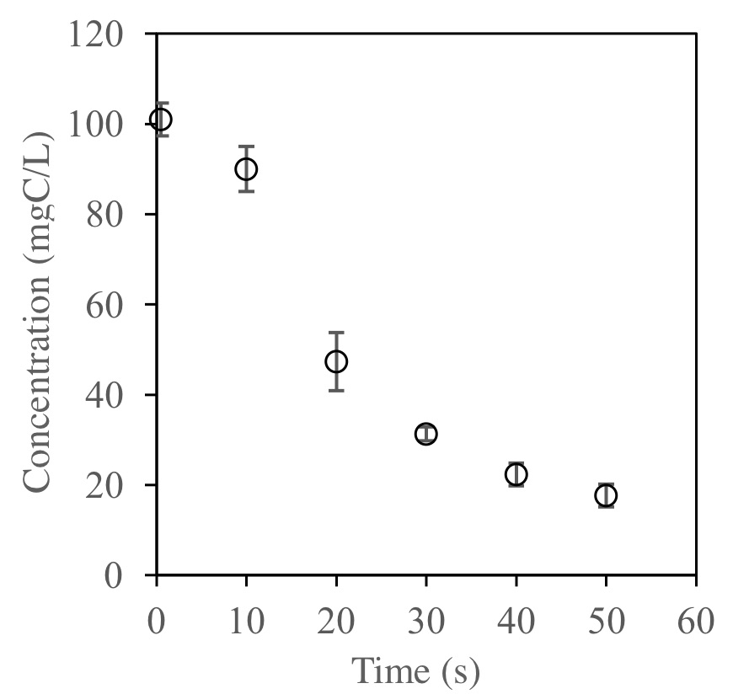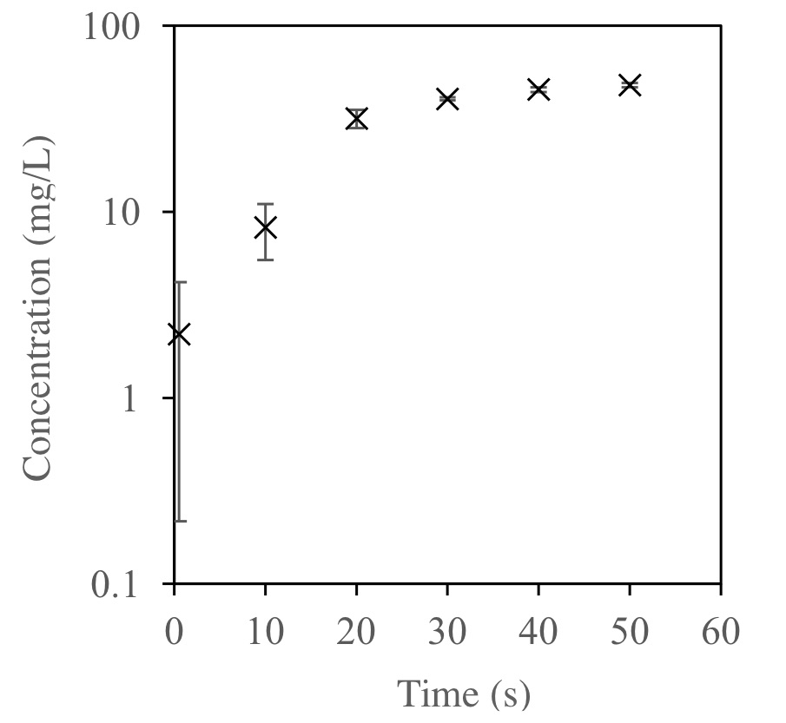
Fig. 1 Conservation and creation of clean water environment. a) Degradation of organic pollutant, and b) production of compound X. Error bar represents standard deviation (n=3).

